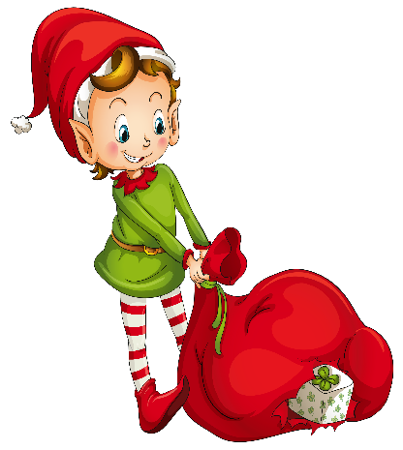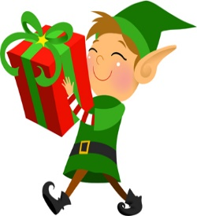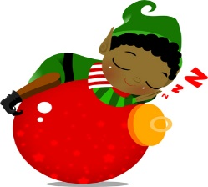 

Santa and his little Elf helpers love hearing about all the lovely kind things children do for other people.

Write a story, a poem or draw a picture to tell him and his helpers something that you have done that was kind and made other people feel happy this year.

We will post a star letter every week from now until Christmas on our Facebook page and the star letters will win a £20 gift voucher for

**The Entertainer toy shop.**

Pop your letters to Pop your letters into

**The Elf Post Box**

**The Moat Family Hub, Deedmore Road, Coventry CV2 1EQ**

Or send to

[Themoatfamilyhub@coventry.gov.uk](mailto:Themoatfamilyhub@coventry.gov.uk)

Good Luck everyone and Merry Christmas

**Facebook - Themoatfamilyhub**