SSPP Year 6 Overview

Units
Autumn  WW11 |  |  |  | Spring  Natural Disasters |  |  | Summer  Survival of the Fittest
Narrative  Setting Description  Diary Entry  Narrative retell | Non-fiction  Missing Person Report  Persuasive Letter |  | Poetry  Winter Poetry |  | Narrative  Emotive Narrative  Short-Burst Creative Writing. | Non-fiction  Balanced Argument  Newspaper Report | Narrative  Recount in role as Character | Non-fiction  Informal Letter  Explanation Text  Leaflet
Suggested Texts for Writing and Reading Skills
These are limited recommendations. Any high-quality text, that fits with the aims of the unit, can be planned from.
Autumn Term:
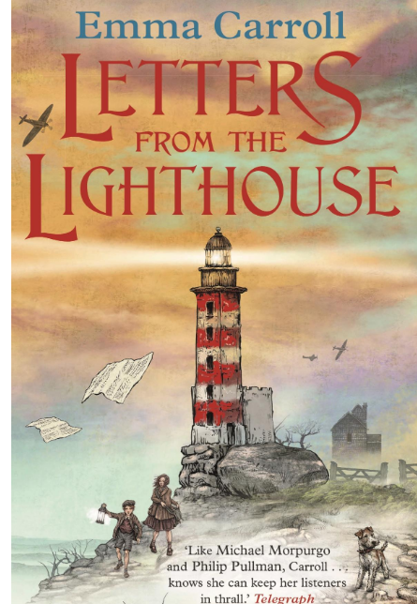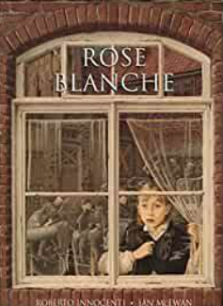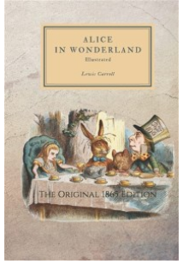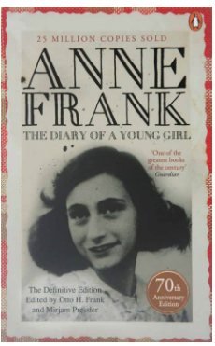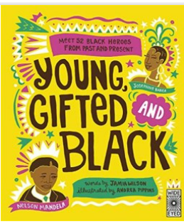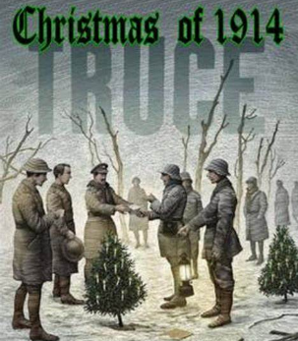
Beyond the Lines

Literacy Shed

Spring Term:
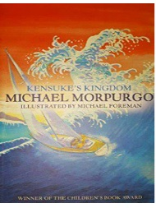
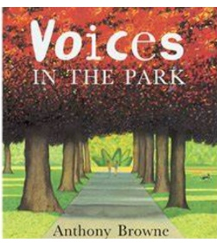

Summer Term:

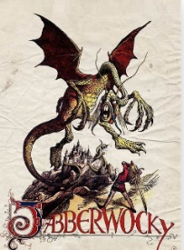
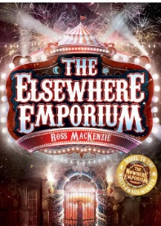
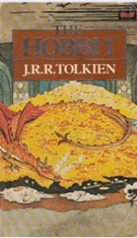
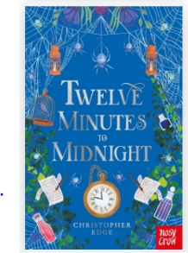

Skills and Knowledge Writing
Decoding |  | - apply their growing knowledge of root words, prefixes and suffixes (morphology and etymology), both to read aloud and to understand the meaning of new words that they meet
Range of  Reading |  | - continuing to read and discuss an increasingly wide range of fiction, poetry, plays, non-fiction and reference books or textbooks  - reading books that are structured in different ways and reading for a range of purposes  - making comparisons within and across books
Familiarity with  texts |  | - increasing their familiarity with a wide range of books, including myths, legends and traditional stories, modern fiction, fiction from our literary heritage, and books from other cultures and traditions  - identifying and discussing themes and conventions in and across a wide range of writing
Poetry &  Performance |  | - learning a wider range of poetry by heart  - preparing poems and plays to read aloud and to perform, showing understanding through intonation, tone and volume so that the meaning is clear to an audience
Understanding |  | - checking that the book makes sense to them, discussing their understanding and exploring the meaning of words in context  - asking questions to improve their understanding  - summarising the main ideas drawn from more than one paragraph, identifying key details to support the main ideas
Inference |  | - drawing inferences such as inferring characters’ feelings, thoughts and motives from their actions, and justifying inferences with evidence
Prediction |  | - predicting what might happen from details stated and implied
Authorial  Intent |  | - identifying how language, structure and presentation contribute to meaning  - discuss and evaluate how authors use language, including figurative language, considering the impact on the reader
Non-fiction |  | - distinguish between statements of fact and opinion  - retrieve, record and present information from non-fiction
Discussing  reading |  | - recommending books that they have read to their peers, giving reasons for their choices  - *participate in discussions about books, building on their own and others’ ideas and challenging views courteously  - *explain and discuss their understanding of what they have read, including through formal presentations and debates,  - provide reasoned justifications for their views

Skills and Knowledge Writing
Phonic & Whole word spelling | - spell some words with ‘silent’ letters  - continue to distinguish between homophones and other words which are often confused  - use knowledge of morphology and etymology in spelling and understand that the spelling of some words needs to be learnt  - specifically, as listed in Appendix 1use further prefixes and suffixes and understand the guidance for adding them  - use dictionaries to check the spelling and meaning of words  - use the first 3 or 4 letters of a word to check spelling, meaning or both of these in a dictionary
Handwriting | - choosing which shape of a letter to use when given choices and deciding whether or not to join specific letters  - choosing the writing implement that is best suited for a task
Contexts for Writing | - identifying the audience for and purpose of the writing, selecting the appropriate form and using other similar writing as models for their own  - in writing narratives, considering how authors have developed characters and settings in what pupils have read, listened to or seen performed
Planning Writing | - noting and developing initial ideas, drawing on reading and research where necessary
Drafting Writing | - selecting appropriate grammar and vocabulary, understanding how such choices can change and enhance meaning  - in narratives, describing settings, characters and atmosphere and integrating dialogue to convey character and advance the action  - précising longer passages  - using a wide range of devices to build cohesion within and across paragraphs  - using further organisational and presentational devices to structure text and to guide the reader
Editing Writing | - assessing the effectiveness of their own and others’ writing  - proposing changes to vocabulary, grammar and punctuation to enhance effects and clarify meaning  - ensuring the consistent and correct use of tense throughout a piece of writing  ensuring correct subject and verb agreement when using singular and plural, distinguishing between the language of speech and writing and choosing the appropriate register proofread for spelling and punctuation errors
Performing Writing | - perform their own compositions, using appropriate intonation, volume, and movement so that meaning is clear.
Vocabulary | - use a thesaurus  - using expanded noun phrases to convey complicated information concisely  - using modal verbs or adverbs to indicate degrees of possibility
Grammar & Terminology | - using the perfect form of verbs to mark relationships of time and cause  - using relative clauses beginning with who, which, where, when, whose, that or with an implied (ie omitted)  - relative pronouns converting nouns or adjectives into verbs  - verb prefixes  - devices to build cohesion, including adverbials of time, place and number, modal verb, relative pronoun, relative clause, parenthesis, bracket, dash, cohesion, ambiguity
Punctuation | - using commas to clarify meaning or avoid ambiguity in writing  - using brackets, dashes or commas to indicate parenthesis  - using hyphens to avoid ambiguity  - using semicolons, colons or dashes to mark boundaries

Spoken language
Pupils should be taught to:
- listen and respond appropriately to adults and their peers
- ask relevant questions to extend their understanding and knowledge
- use relevant strategies to build their vocabulary
- articulate and justify answers, arguments and opinions
- give well-structured descriptions, explanations and narratives for different purposes, including for expressing feelings
- maintain attention and participate actively in collaborative conversations, staying on topic and initiating and responding to comments
- use spoken language to develop understanding through speculating, hypothesising, imagining and exploring ideas
- speak audibly and fluently with an increasing command of Standard English
- participate in discussions, presentations, performances, role play/improvisations and debates
- gain, maintain and monitor the interest of the listener(s)
- consider and evaluate different viewpoints, attending to and building on the contributions of others
- select and use appropriate registers for effective communication

