SSPP Year 1 Overview

Topic
Autumn  Me and My World |  |  |  | Spring  Kings, Queens and Castles |  |  | Summer  Seaside
Narrative  Story Retell  Recount  Setting Description  Letter | Non Fiction  Labels and captions  Non-Chronological Report |  |  | Winter  Poetry (2 weeks)  Learn and retell  Shape Poetry | Narrative  Traditional Tales  Stories  Innovations  Letters | Non Fiction  Instructions | Narrative  Story Retell  Character Description  Letter  Recount | Non fiction  Information Leaflet
Suggested Texts for Writing and Reading skills
These are limited recommendations. Any high-quality text, that fits with the aims of the unit, can be planned from.
Autumn: Term:
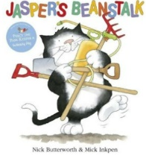
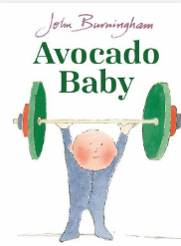
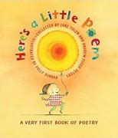
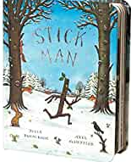
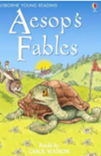
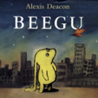
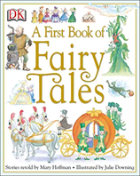

Spring Term:
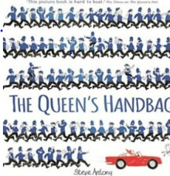
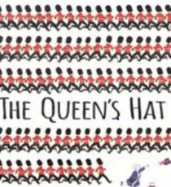
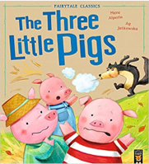
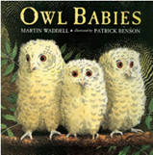
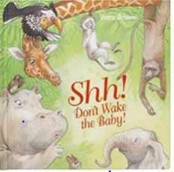
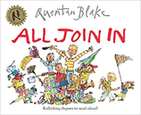
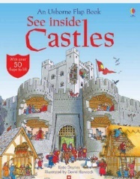
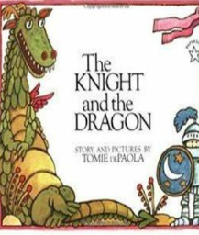
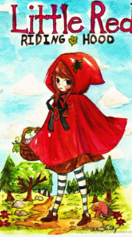
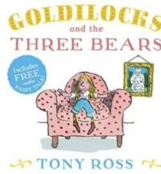

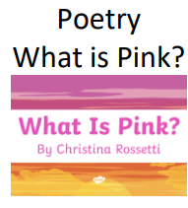
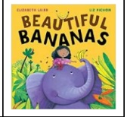
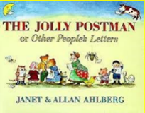
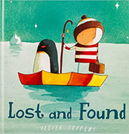
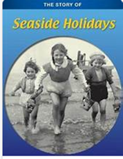
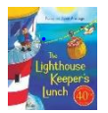
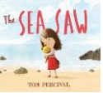
Summer Term:
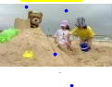

Skills and Knowledge Year 1 Reading
Range of reading |  | - apply phonic knowledge to decode words  - speedily read all 40+ letters/groups for 40+ phonemes  - read accurately by blending taught GPC  - read common exception words  - read common suffixes (-s, -es, -ing, -ed, etc.)  - read multisyllable words containing taught GPCs  - read contractions and understanding use of apostrophe •read aloud phonically-decodable texts
Decoding |  | - listening to and discussing a wide range of poems, stories and non-fiction at a level beyond that at which they can read independently  - being encouraged to link what they read or hear read to their own experiences
Familiarity with texts |  | - becoming very familiar with key stories, fairy stories and traditional tales, retelling them and considering their particular characteristics  - *recognising and joining in with predictable phrases
Poetry |  | - *learning to appreciate rhymes and poems, and to recite some by heart
Word means |  | - *discussing word meanings, linking new meanings to those already known
Understanding |  | - drawing on what they already know or on background information and vocabulary provided by the teacher  - *checking that the text makes sense to them as they read and correcting inaccurate reading
Inference |  | - discussing the significance of the title and events  - *making inferences on the basis of what is being said and done
prediction |  | - *predicting what might happen on the basis of what has been read so far
Discussing reading |  | - *participate in discussion about what is read to them, taking turns and listening to what others say  - *explain clearly their understanding of what is read to them
Skills and Knowledge Year 1 Writing
Phonic &  Whole word  spelling |  |  | • words containing each of the 40+ phonemes taught  • common exception words  • the days of the week  • name the letters of the alphabet in order using letter names to distinguish between alternative spellings of the same sound
Other word  building  spelling |  |  | • using the spelling rule for adding –s or –es as the plural marker for nouns and the third person singular marker for verbs using the prefix un–  • using –ing, –ed, –er and –est where no change is needed in the spelling of root words  • apply simple spelling rules and guidance from Appendix 1
Transcription |  |  | • write from memory simple sentences dictated by the teacher that include words using the GPCs and common exception words taught so far.
Handwriting |  |  | • sit correctly at a table, holding a pencil comfortably and correctly  • begin to form lower-case letters in the correct direction, starting and finishing in the right place  • form capital letters  • form digits 0-9  • understand which letters belong to which handwriting families’ and to practise these
Planning  Writing |  |  | • saying out loud what they are going to write about  • composing a sentence orally before writing it
Drafting Writing |  |  | • sequencing sentences to form short narratives • re-reading what they have written to check that it makes sense
Editing Writing |  |  | • discuss what they have written with the teacher or other pupils
Performing  Writing |  |  | • read their writing aloud clearly enough to be heard by their peers and the teacher.
Vocabulary |  |  | • leaving spaces between words  • joining words and joining clauses using "and"
Grammar |  |  | • regular plural noun suffixes (-s, -es)  • verb suffixes where root word is unchanged (-ing, -ed, -er)  • un- prefix to change meaning of adjectives/adverbs  • to combine words to make sentences, including using and Sequencing sentences to form short narratives  • separation of words with spaces  • sentence demarcation (. ! ?)  • capital letters for names and pronoun 'I')
Punctuation |  |  | • beginning to punctuate sentences using a capital letter and a full stop, question mark or exclamation mark  • using a capital letter for names of people, places, the days of the week, and the personal pronoun ‘I’
Grammatical  Terminology |  |  | letter, capital letter, word, singular, plural , sentence punctuation, full stop, question mark, exclamation mark

Spoken language
Pupils should be taught to:
- listen and respond appropriately to adults and their peers
- ask relevant questions to extend their understanding and knowledge
- use relevant strategies to build their vocabulary
- articulate and justify answers, arguments and opinions
- give well-structured descriptions, explanations and narratives for different purposes, including for expressing feelings
- maintain attention and participate actively in collaborative conversations, staying on topic and initiating and responding to comments
- use spoken language to develop understanding through speculating, hypothesising, imagining and exploring ideas
- speak audibly and fluently with an increasing command of Standard English
- participate in discussions, presentations, performances, role play/improvisations and debates
- gain, maintain and monitor the interest of the listener(s)
- consider and evaluate different viewpoints, attending to and building on the contributions of others
- select and use appropriate registers for effective communication

