SSPP Year 2 Overview

Units
Autumn  The Great Fire of London |  |  |  | Spring  Exploring the UK |  |  | Summer  Our Wonderful World
Narrative  Retell - Traditional Tales  Innovate - Traditional Tale | Non-Fiction  Non-Chronological Report  Instructions |  | Winter  Poetry  Expanded Noun Phrases |  | Narrative  Retell  Innovate  Character Description | Non-fiction  Crime Report  Information Text | Narrative  5-Part Story | Non-Fiction  Postcard  Diary Entry | Poetry  Rhyming
Suggested Texts for Writing and Reading skills
These are limited recommendations. Any high-quality text, that fits with the aims of the unit, can be planned from.
Autumn Term:
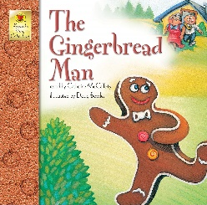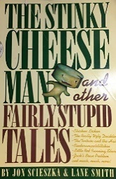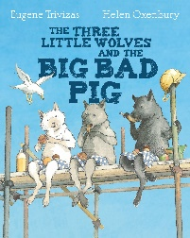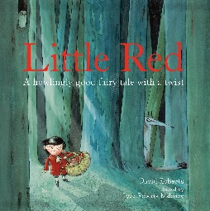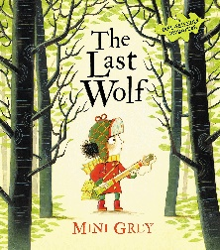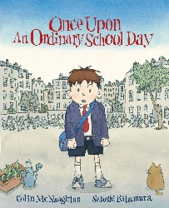
Spring Term:
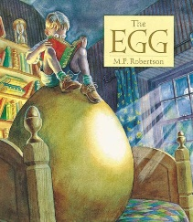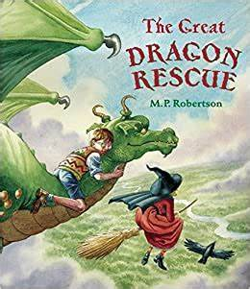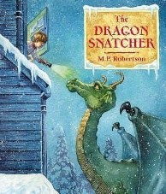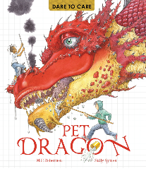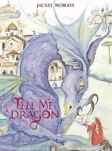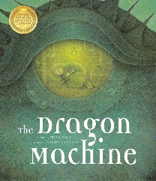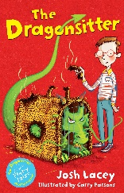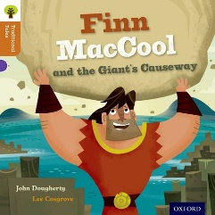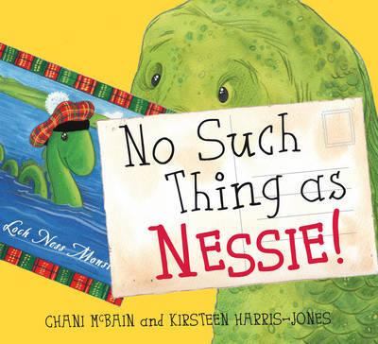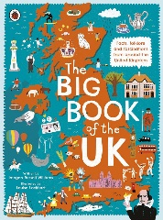
Summer Term:
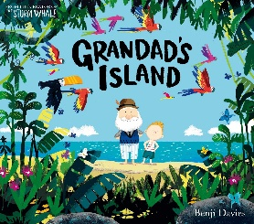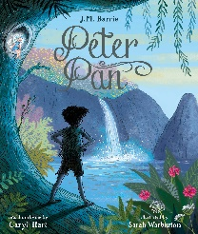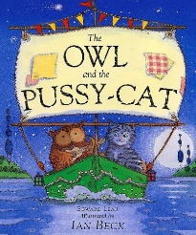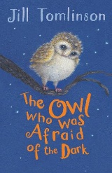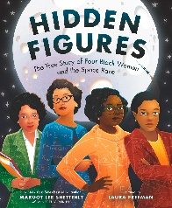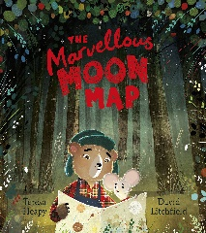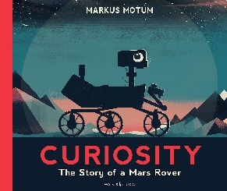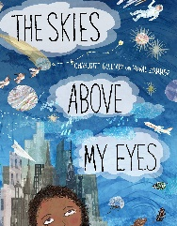
Skills and Knowledge Reading
Decoding |  | - secure phonic decoding until reading is fluent  - read accurately by blending, including alternative sounds for graphemes  - read multisyllable words containing these graphemes  - read common suffixes  - read exception words, noting unusual correspondences  - read most words quickly & accurately without overt sounding and blending
Range of Reading |  | - listening to, discussing and expressing views about a wide range of contemporary and classic poetry, stories and non-fiction at a level beyond that at which they can read independently
Familiarity with  texts |  | - becoming increasingly familiar with and retelling a wider range of stories, fairy stories and traditional tales  - recognising simple recurring literary language in stories and poetry
Poetry &  Performance |  | - continuing to build up a repertoire of poems learnt by heart, appreciating these and reciting some, with appropriate intonation to make the meaning clear
Word meanings |  | - discussing and clarifying the meanings of words, linking new meanings to known vocabulary  - discussing their favourite words and phrases
Understanding |  | - discussing the sequence of events in books and how items of information are related  - drawing on what they already know or on background information and vocabulary provided by the teacher  - checking that the text makes sense to them as they read and correcting inaccurate reading
Inference |  | - making inferences on the basis of what is being said and done  - answering and asking questions
Prediction |  | - predicting what might happen on the basis of what has been read so far
Non-fiction |  | - being introduced to non-fiction books that are structured in different ways
Discussing reading |  | - participate in discussion about books, poems & other works that are read to them & those that they can read for themselves, taking turns and listening to what others say  - explain and discuss their understanding of books, poems and other material, both those that they listen to and those that they read for themselves

Skills and Knowledge Writing
Phonic & Whole Word Spelling | - segmenting spoken words into phonemes and representing these by graphemes, spelling many correctly  - learning new ways of spelling phonemes for which 1 or more spellings are already known, and learn some words with each spelling, including a few common homophones  - learning to spell common exception words  - distinguishing between homophones and near-homophones  - learning the possessive apostrophe (singular)  - learning to spell more words with contracted forms  - add suffixes to spell longer words, including –ment, –ness, –ful, –less, –ly  - apply spelling rules and guidelines from Appendix 1
Transcription | - write from memory simple sentences dictated by the teacher that include words using the GPCs, common exception words and punctuation taught so far
Handwriting | - form lower-case letters of the correct size relative to one another  - start using some of the diagonal and horizontal strokes needed to join letters and understand which letters, when adjacent to one another, are best left un-joined  - write capital letters and digits of the correct size, orientation and relationship to one another and to lower-case letters  - use spacing between words that reflects the size of the letters
Contexts for Writing | - writing narratives about personal experiences and those of others (real and fictional)  - writing about real events  - writing poetry  - writing for different purposes
Planning Writing | - planning or saying out loud what they are going to write about
Drafting Writing | - writing down ideas and/or key words, including new vocabulary  - encapsulating what they want to say, sentence by sentence
Editing Writing | - evaluating their writing with the teacher and other pupils  - rereading to check that their writing makes sense and that verbs to indicate time are used correctly and consistently, including verbs in the continuous form  - proofreading to check for errors in spelling, grammar and punctuation
Performing Writing | - read aloud what they have written with appropriate intonation to make the meaning clear
Vocabulary | - expanded noun phrases to describe and specify
Grammar | - sentences with different forms: statement, question, exclamation, command  - the present and past tenses correctly and consistently including the progressive form  - subordination (using when, if, that, or because) and coordination (using or, and, or but)  - some features of written Standard English  - suffixes to form new words (-ful, -er, -ness)  - sentence demarcation  - commas in lists  - apostrophes for omission & singular possession
Punctuation | - learning how to use both familiar and new punctuation correctly, including full stops, capital letters, exclamation marks, question marks, commas for lists and apostrophes for contracted forms and the possessive (singular)
Grammatical  Terminology | - noun, noun phrase, statement, question, exclamation, command, compound, adjective, verb, suffix, adverb  - tense (past, present), apostrophe, comma

Spoken language
Pupils should be taught to:
- listen and respond appropriately to adults and their peers
- ask relevant questions to extend their understanding and knowledge
- use relevant strategies to build their vocabulary
- articulate and justify answers, arguments and opinions
- give well-structured descriptions, explanations and narratives for different purposes, including for expressing feelings
- maintain attention and participate actively in collaborative conversations, staying on topic and initiating and responding to comments
- use spoken language to develop understanding through speculating, hypothesising, imagining and exploring ideas
- speak audibly and fluently with an increasing command of Standard English
- participate in discussions, presentations, performances, role play/improvisations and debates
- gain, maintain and monitor the interest of the listener(s)
- consider and evaluate different viewpoints, attending to and building on the contributions of others
- select and use appropriate registers for effective communication

