SSPP Year 4 Overview

Topic
Autumn  The Roman Empire |  |  |  | Spring  Falling Rainforests |  |  | Summer  Rolling Rivers
Narrative  Emotive First-Person Narrative | Non-fiction  Non-Chronological report  Information text |  | Winter  Poetry |  | Narrative  Setting Description  Innovated Narrative  Emotive recount | Non-fiction  Persuasive Speech | Narrative  Suspense Writing | Non-fiction  Informal Letter  Newspaper report  Explanation Text
Suggested Texts For Writing and Reading skills
These are limited recommendations. Any high-quality text, that fits with the aims of the unit, can be planned from.
Autumn Term:
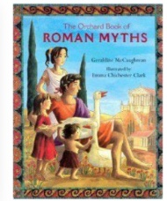
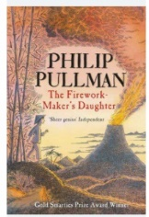
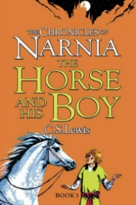
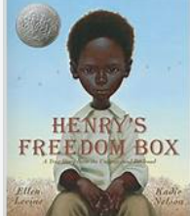
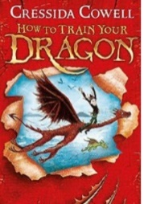
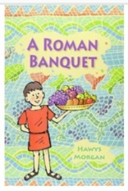

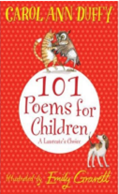
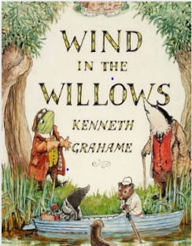
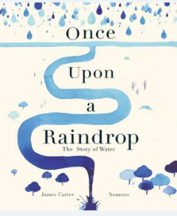
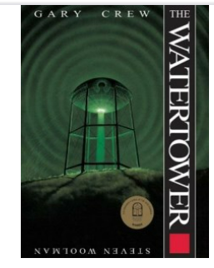
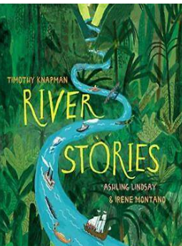
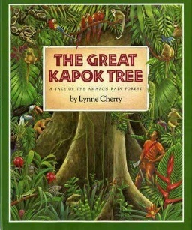
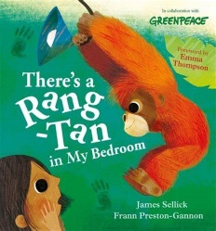
Spring Term:
Summer Term:
Skills and Knowledge Reading
Decoding |  | - apply their growing knowledge of root words, prefixes and suffixes, both to read aloud and to understand the meaning of new words they meet  - read further exception words, noting the unusual correspondences between spelling and sound, and where these occur in the word
Range of  Reading |  | - listening to and discussing a wide range of fiction, poetry, plays, non-fiction and reference books or textbooks reading books that are structured in different ways and reading for a range of purposes
Familiarity with  texts |  | - increasing their familiarity with a wide range of books, including fairy stories, myths and legends, and retelling some of these orally  - identifying themes and conventions in a wide range of books
Poetry &  Performance |  | - preparing poems and play scripts to read aloud and to perform, showing understanding through intonation, tone, volume and action  - recognising some different forms of poetry
Word meanings |  | - using dictionaries to check the meaning of words that they have read
Understanding |  | - checking that the text makes sense to them, discussing their understanding and explaining the meaning of words in context  - asking questions to improve their understanding of a text  - identifying main ideas drawn from more than one paragraph and summarising these
Inference |  | - drawing inferences such as inferring characters’ feelings, thoughts and motives from their actions, and justifying inferences with evidence
Prediction |  | - predicting what might happen from details stated and implied
Authorial  Intent |  | - discussing words and phrases that capture the reader’s interest and imagination  - identifying how language, structure, and presentation contribute to meaning
Non-fiction |  | - retrieve and record information from non-fiction
Discussing  reading |  | - participate in discussion about both books that are read to them and those they can read for themselves, taking turns and listening to what others say

Skills and Knowledge Writing
Phonic & Whole word spelling | - spell further homophones  - spell words that are often misspelt (Appendix 1)  - use further prefixes and suffixes and understand how to add them  - place the possessive apostrophe accurately in words with regular plurals and in words with irregular plurals  - use the first 2 or 3 letters of a word to check its spelling in a dictionary
Transcription | - write from memory simple sentences, dictated by the teacher, that include words and punctuation taught so far
Handwriting | - use further prefixes and suffixes and understand how to add them  - place the possessive apostrophe accurately in words with regular plurals and in words with irregular plurals  - use the first 2 or 3 letters of a word to check its spelling in a dictionary
Contexts for Writing | - discussing writing similar to that which they are planning to write in order to understand and learn from its structure, vocabulary and grammar
Planning Writing | - discussing and recording ideas  - composing and rehearsing sentences orally (including dialogue), progressively building a varied and rich vocabulary and an increasing range of sentence structures
Drafting Writing | - organising paragraphs around a theme  - in narratives, creating settings, characters and plot  - in non-narrative material, using simple organisational devices
Editing Writing | - assessing the effectiveness of their own and others’ writing and suggesting improvements  - proposing changes to grammar and vocabulary to improve consistency, including the accurate use of pronouns in  - Sentences  - proofread for spelling and punctuation errors
Performing Writing | - read their own writing aloud, to a group or the whole class, using appropriate intonation and controlling the tone and volume so that the meaning is clear
Vocabulary | - extending the range of sentences with more than one clause by using a wider range of conjunctions, including when, if, because, although  - choosing nouns or pronouns appropriately for clarity and cohesion and to avoid repetition
Grammar & Terminology | - using fronted adverbials  - difference between plural and possessive -s  - Standard English verb inflections (I did vs I done)  - extended noun phrases, including with prepositions  - appropriate choice of pronoun or noun to create cohesion  determiner, pronoun, possessive pronoun, adverbial
Punctuation | - • using commas after fronted adverbials  - indicating possession by using the possessive apostrophe with singular and plural nouns  - using and punctuating direct speech (including punctuation within and surrounding inverted commas)

Spoken language
Pupils should be taught to:
- listen and respond appropriately to adults and their peers
- ask relevant questions to extend their understanding and knowledge
- use relevant strategies to build their vocabulary
- articulate and justify answers, arguments and opinions
- give well-structured descriptions, explanations and narratives for different purposes, including for expressing feelings
- maintain attention and participate actively in collaborative conversations, staying on topic and initiating and responding to comments
- use spoken language to develop understanding through speculating, hypothesising, imagining and exploring ideas
- speak audibly and fluently with an increasing command of Standard English
- participate in discussions, presentations, performances, role play/improvisations and debates
- gain, maintain and monitor the interest of the listener(s)
- consider and evaluate different viewpoints, attending to and building on the contributions of others
- select and use appropriate registers for effective communication

